Lab:02

Experiment Name: Implementation of half adder using basic gates.

**Equipment:**

1. Trainer board
2. Bread board
3. IC
4. Connecting wire
5. Wire cutter

**Theory:**

Half Adder is a combinational circuit that performs addition of two bits. It has two inputs and two outputs. The two I/Ps are the two 1-bit numbers A and B designated as augend and addend bits. The two O/Ps are the sum ‘S’ of A and B and the carry bit, denoted by ‘C’. Truth table of a half adder can be derived by performing binary addition of augend and addend bits as follows:

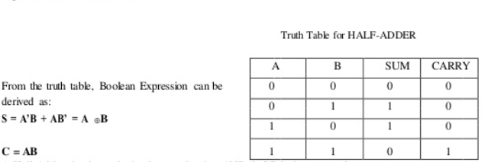

**Diagram:**

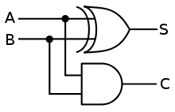

**Pin Diagram:**

